Question 1) Let us assume we implement an AND function to a single neuron. Below is a tabular representation of an AND function:
X1 | X2 | X1 AND X2
0 | 0 | 0
0 | 1 | 0
1 | 0 | 0
1 | 1 | 1
The activation function of our neuron is denoted as:
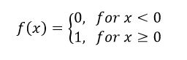

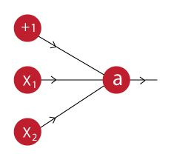

What would be the weights and bias?

Question 2) In the graph below, we observe that the error has many “ups and downs”
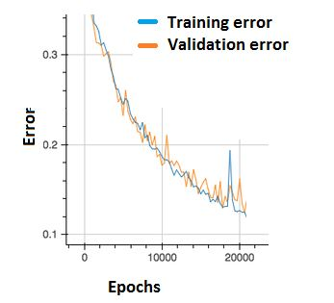
Should we be worried?
A. Yes, because this means there is a problem with the learning rate of neural network.
B. No, as long as there is a cumulative decrease in both training and validation error, we don’t need to worry.

Question 3) The network shown in Figure 1 is trained to recognize the characters H and T as shown below:
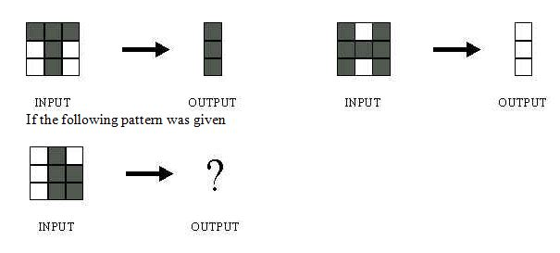
What would be the output of the network?
- 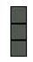

- 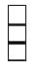

- 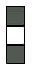

D) Could be A or B depending on the weights of neural network

Question 4)
